SOFTWARE DESIGN DOCUMENT (SDD)

Hotel Reservation System (HMS)
1. DOCUMENT CONTROL
Item | Details
Project Name | Hotel Management System
Version | 1.0
Author | Saksham Omar
Date | (Date)
Status | Draft

2. PURPOSE OF THE DOCUMENT
This Software Design Document (SDD) provides a detailed description of the architecture, design decisions, component structure, service responsibilities, APIs, data design principles, security considerations, and non-functional requirements of the Hotel Reservation System.
The purpose of this document is to::
- Serve as a blueprint for implementation
- Ensure clear separation of responsibilities across microservices
- Capture real-world hotel business rules
- Maintenance & enhancement planning
- Enable scalability, maintainability, and security
- Act as a reference for:
- Developers
- Reviewers
- Interview discussions
- Future enhancements and maintenance
This document follows enterprise-grade software engineering practices and is aligned with industry expectations for distributed systems.

3. SYSTEM OVERVIEW

3.1 Business Objective
The Hotel Reservation System is designed to support a hotel chain operating across multiple cities and properties. The system aims to replace manual or semi-automated reservation processes with a centralized, secure, and scalable digital platform.
The system enables:
- Real-time room availability management
- Online room reservations and cancellations
- Accurate check-in and check-out workflows
- Secure user authentication and role-based access
- Operational visibility through reports and notifications

3.2 High-Level Features
- User authentication and authorization (JWT-based)
- Hotel and room category management
- Room availability tracking by date range
- Reservation lifecycle management
- Asynchronous notifications
- Reporting using CQRS-style read models

3.3 User Roles
- Admin: Manages system-wide configurations and users
- Hotel Manager: Manages hotel rooms and availability
- Receptionist: Handles check-in and check-out operations
- Guest: Searches rooms and makes reservations

4. ARCHITECTURE OVERVIEW (HLD)
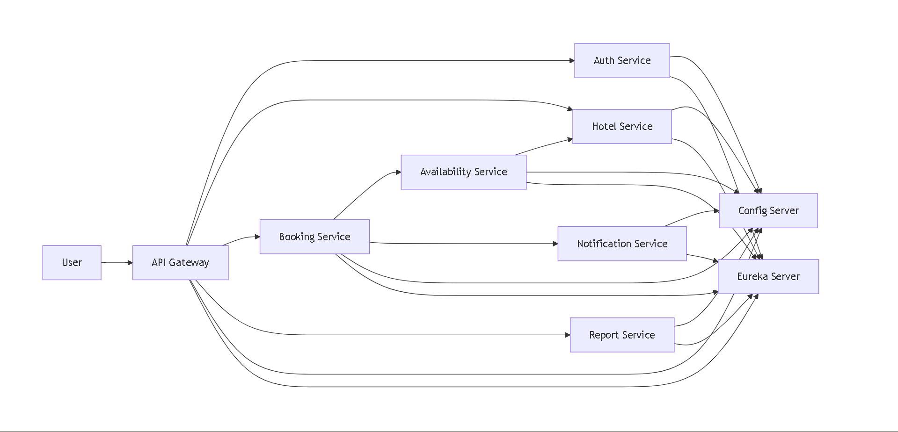
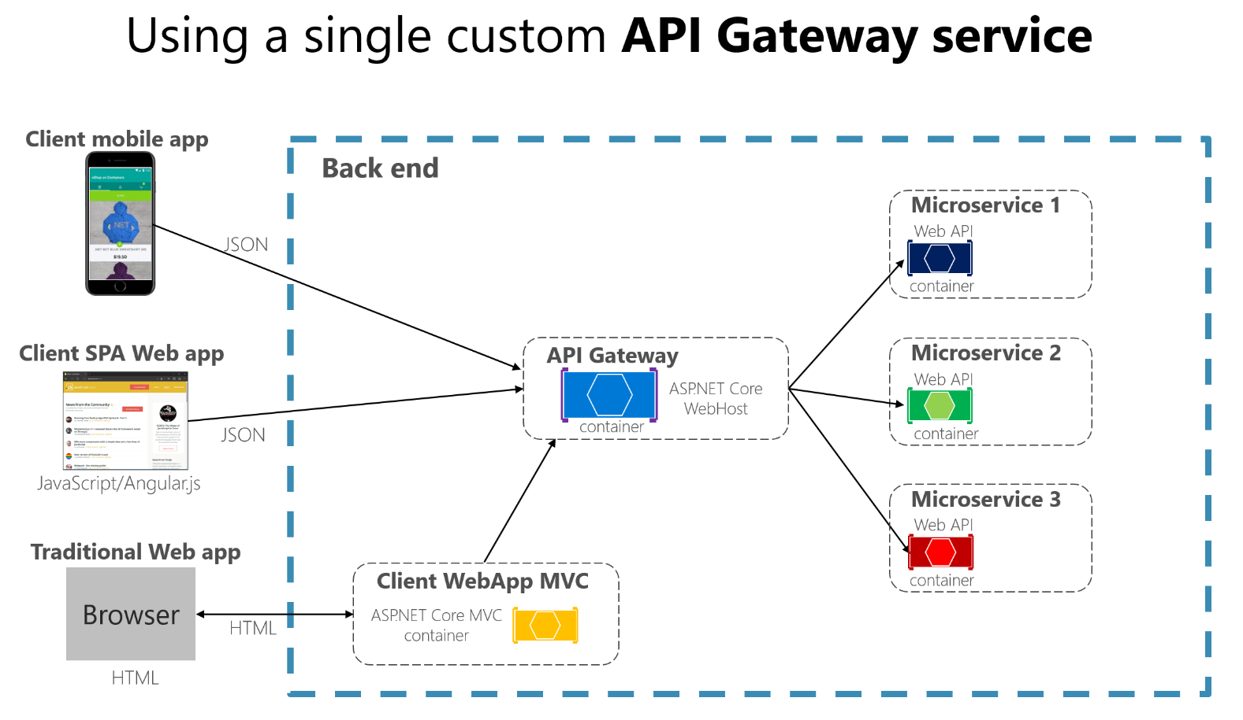

4.1 Architecture Style

The system follows a Microservices Architecture with the following characteristics:
- Each business capability is implemented as an independent service
- Services communicate via REST APIs and asynchronous events
- Centralized configuration and service discovery
- Stateless backend services
- Cloud-ready and container-friendly design

4.2 Core Components

4.2.1 Platform / Infrastructure Services
(a) API Gateway
- Single entry point for all client requests
- Routes requests to appropriate microservices
- Performs JWT validation and request filtering
(b) Config Server
- Centralized external configuration management
- Environment-specific configuration support
(c) Service Registry
- Service discovery using Eureka
- Enables dynamic service lookup and load balancing

4.2.2 Business Microservices
- Auth Service
- Hotel Service
- Availability Service
- Booking Service
- Notification Service (Asynchronous)
- Reporting Service (CQRS-based)

4.3 High-Level Interaction Flow
(a) Client sends request to API Gateway
(b) API Gateway validates JWT and routes request
(c) Auth Service manages identity and access control
(d) Booking Service orchestrates reservation workflows
(e) Availability Service validates and locks room availability
(f) Hotel Service provides room and pricing metadata
(g) Notification Service sends async alerts
(h) Reporting Service consumes events for analytics
Note: Each microservice owns its database and enforces business rules within its service boundary.
- TECHNOLOGY STACK

The Hotel Reservation System is built using a modern, production-ready technology stack aligned with current enterprise standards. The chosen technologies ensure scalability, security, maintainability, and ease of deployment in cloud-native environments.

Backend
- Java 17+
- Spring Boot 3.x
- Spring Web (REST APIs)
- Spring Data JPA & Hibernate
- Spring Security
- Spring Cloud Components
- OpenFeign / RestTemplate

Frontend
- Angular
- Angular Material
- TypeScript
- HttpClient & Interceptors

Database
- Relational Database (MySQL / PostgreSQL)
- ACID Compliance
- Strong consistency for transactional operations
- Database per Microservice Pattern
- Each microservice owns its schema
- No shared databases between services
- MongoDB for event-driven workloads like notifications

DevOps
- Docker
- Docker Compose
- Jenkins
- SonarQube

Testing
- JUnit 5
- Mockito
- Spring Boot Test
- Postman
Note: Each microservice owns its database and enforces business rules strictly within its service boundary.
- MICROSERVICES DESIGN

This section provides a detailed description of each business microservice in the Hotel Reservation System. Each microservice is independently deployable, owns its database, and encapsulates its business rules. The design strictly follows single responsibility, database-per-service, and loose coupling principles.
  - Auth Service
6.1.1 Purpose
The Auth Service is responsible for authentication, authorization, and identity management across the system. It acts as the central security authority.
6.1.2 Responsibilities
- User registration and login
- Role-based access control (RBAC)
- JWT token generation and validation
- Password encryption and credential validation
6.1.3 Key APIs (High Level)
POST /auth/register
POST /auth/login
GET /auth/me
GET /auth/validate (internal)
6.1.4 Database
- Users
- Roles
- User-role mappings
- Authentication metadata
6.1.5 Business Rules
- Email must be unique
- Passwords must be encrypted (BCrypt)
- Only ADMIN users can manage roles
- JWT is mandatory for protected APIs
  - Hotel Service
6.2.1 Purpose

The Hotel Service manages hotel master data and room configuration. It provides reference data for other services.
6.2.2 Responsibilities
- Manage hotels (name, city, address)
- Manage room categories (Single, Double, Deluxe, Suite)
- Define room capacity
- Maintain base pricing per room category
6.2.3 Key APIs (High Level)
POST /hotels
GET /hotels
GET /hotels/{hotelId}
GET /hotels/{hotelId}/room-categories
6.2.4 Database
- Hotels
- Room Categories
- Hotel-room categories
6.2.5 Business Rules
- Each hotel must have at least one room category
- Base price must be greater than zero
- Only ADMIN or HOTEL_MANAGER can modify data
  - Availability Service
6.3.1 Purpose

The Availability Service ensures accurate room availability and prevents double booking under concurrent access.
6.3.2 Responsibilities
- Track room availability by date range
- Detect overlapping bookings
- Lock inventory during booking flow
- Maintain room status (AVAILABLE, OCCUPIED, MAINTENANCE)
6.3.3 Key APIs (High Level)
GET /availability/search
POST /availability/lock
POST /availability/release
6.3.4 Database
- Room inventory
- Availability calender
- Room status records
6.3.5 Business Rules
- Overlapping date ranges are not allowed
- Locked inventory must expire if not confirmed
- Rooms under MAINTENANCE cannot be booked

6.4 Booking Service
6.4.1 Purpose

The Booking Service manages the reservation lifecycle and orchestrates interactions with Availability, Hotel, and Payment systems.
6.4.2 Responsibilities
- Create and manage reservations
- Validate booking dates
- Handle booking status transitions
- Manage check-in and check-out
- Calculate stay duration and total amount
6.4.3 Key APIs (High Level)
POST /bookings
GET /bookings/{id}
PUT /bookings/{id}/cancel
PUT /bookings/{id}/check-in
PUT /bookings/{id}/check-out
6.4.4 Database
- Bookings
- Booking guests
- Booking status history
6.4.5 Business Rules
- Availability must be confirmed before booking
- Invalid status transitions are rejected
- Check-in date must match booking start date
- Check-out cannot occur before check-in

6.5 Notification Service
6.5.1 Purpose
The Notification Service handles asynchronous, event-driven notifications to users without blocking core business workflows.
6.5.2 Responsibilities
- Consume domain events (booking created, confirmed, cancelled, checked-in, checked-out)
- Send notifications via email/SMS (basic simulation)
- Track notification delivery status
6.5.3 Key APIs (High Level)
Event consumer (message broker)
POST /notifications/internal/send
6.5.4 Database (NoSQL - MongoDB)
- Notification events
- Delivery logs
- Retry metadata
6.5.5 Business Rules
- Notification failures must not impact booking flow
- Failed notifications can be retried asynchronously
- Notifications are best-effort, not transactional

6.6 Report Service (CQRS Pattern)
6.6.1 Purpose
The Reporting Service provides read-only, aggregated analytical views of the system using the CQRS (Command Query Responsibility Segregation) pattern.
6.6.2 Responsibilities
- Consume events from Booking and Availability services
- Build read-optimized data models
- Provide dashboards and summary reports
6.6.3 Key APIs (High Level)

GET /reports/occupancy
GET /reports/revenue
GET /reports/reservations
6.6.4 Database (NoSQL - MongoDB)
- Daily occupancy statistics
- Revenue per hotel
- Reservation summaries by dates
6.6.5 Business Rules
- Data is eventually consistent
- No direct write operations from client APIs
- Reporting data is derived only from events
Design Note: Notification and Reporting services are fully decoupled from transactional services and communicate exclusively via asynchronous events, ensuring scalability and fault isolation.

